Day 3:
Variance

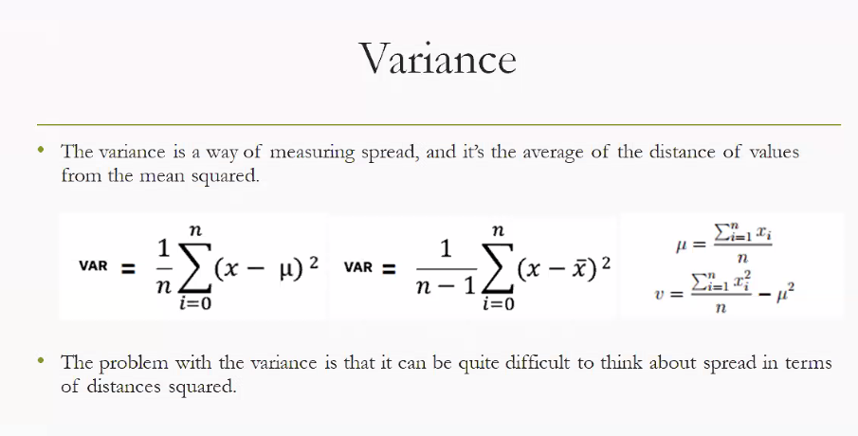
Variance measures how spread-out data is around the mean. It tells us whether values are tightly clustered or widely scattered.
- Formula for a population:
$$σ^{2}=\frac{∑(x_{i}-μ)^{2}}{N}$$
- Formula for a sample:
$$s^{2}=\frac{∑(x_{i}-\overset{ˉ}{x})^{2}}{n-1}$$
Where:
- $x_{i}$= each data point
- $μ$= population mean
- $\overset{ˉ}{x}$= sample mean
- $N$= population size
- $n$= sample size

Step-by-Step Example
Suppose we have data: [2, 4, 6, 8]
- Find the mean: $\overset{ˉ}{x}=(2+4+6+8)/4=5$
- Subtract mean from each value (deviation): $[2-5,4-5,6-5,8-5]=[-3,-1,1,3]$
- Square deviations: $[9,1,1,9]$
- Average them (population variance): $σ^{2}=(9+1+1+9)/4=20/4=5$
So, variance = 5.

Key Insights
- Variance is always non-negative (since deviations are squared).
- A higher variance means more spread in data.
- The square root of variance is the standard deviation, which is easier to interpret in the same units as the data.
- Standard deviation is more useful parameters when you want to convey the results.
- Taking the square root of variance gives standard deviation, which is in the same units as the data.

Why Do We Square Deviations?
- Avoid cancellation
  - Deviations from the mean can be positive or negative.
  - If we just summed them, they’d cancel out to zero (since the mean balances the data).
  - Squaring ensures all deviations are positive, so we measure total spread without cancellation.

- Emphasize larger differences
  - Squaring magnifies bigger deviations more than smaller ones.
  - Example: a deviation of 5 contributes $25$, while a deviation of 1 contributes only $1$.
  - This makes variance sensitive to outliers, which is often useful in statistics.
Comparative Usefulness
Aspect | Variance | Standard Deviation
Definition | Average of squared deviations from the mean | Square root of variance
Units | Squared units (e.g., cm², ₹²) | Same units as the data (e.g., cm, ₹)
Interpretability | Harder to interpret directly because of squared units | Easy to interpret since it’s in the same scale as the data
Mathematical role | Useful in theoretical work, probability, regression, ANOVA, etc. | Useful in practical communication, descriptive statistics, and decision-making
Sensitivity to outliers | Strong (squares exaggerate large deviations) | Also strong, but easier to explain in real-world terms
Applications | - Variance decomposition (ANOVA, regression) <br> - Risk modeling in squared terms <br> - Mathematical proofs and derivations | - Measuring volatility in finance <br> - Quality control in manufacturing <br> - Normal distribution ranges (68–95–99.7 rule)
Preferred for | Theoretical/statistical modeling | Practical interpretation and reporting

- variance is the engine, standard deviation is the dashboard reading. You need variance to build the model, but you look at standard deviation to understand the spread in real life.
• Variance = powerful in theory, modelling, and statistical decomposition.
• Standard Deviation = intuitive, communicable, and practical for everyday decision-making.

Case Study 2: Stock Market Volatility
Suppose we analyse daily returns of two stocks.
- Stock X: Mean return = 0.5%, Variance = 0.0004, Standard Deviation = 2%
- Stock Y: Mean return = 0.5%, Variance = 0.0025, Standard Deviation = 5%

Interpretation:
- Variance (0.0004 vs 0.0025) is useful in portfolio theory, where risk models combine variances and covariances.
- Standard Deviation (2% vs 5%) is what investors care about: Stock Y fluctuates much more, so it’s riskier.
- 👉 Finance professionals rely on variance for mathematical modelling, but communicate risk using standard deviation.

Measures of Symmetricity:
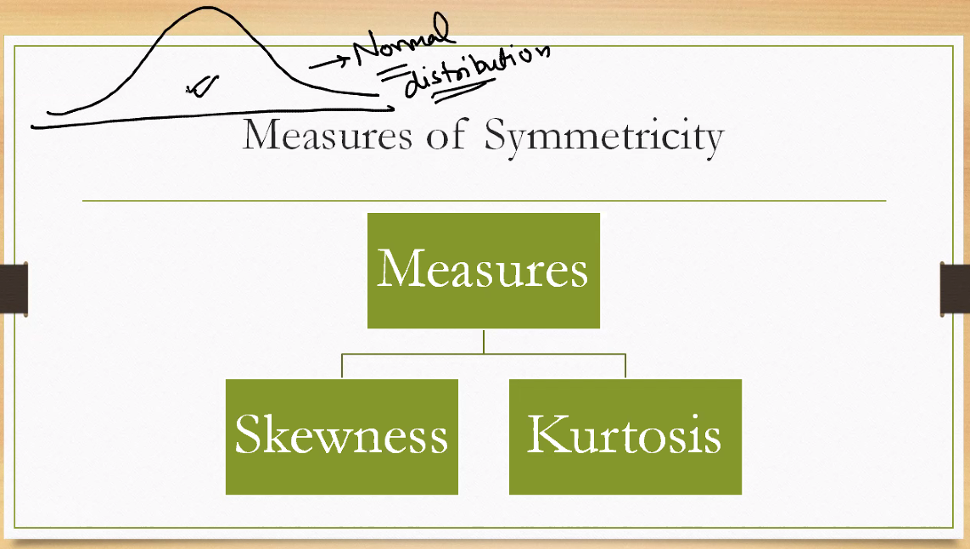
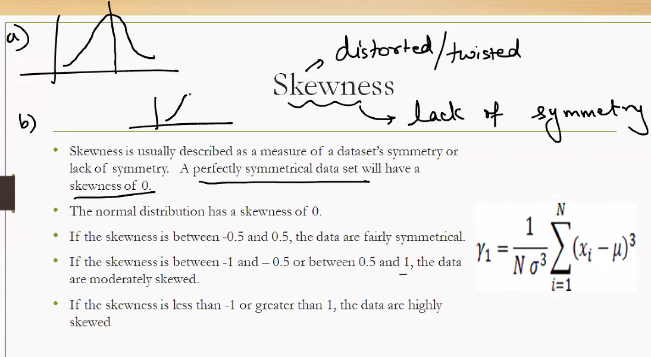
🔄 Skewness: Measuring Asymmetry
Skewness tells us whether the data leans more to one side of the mean.
- Positive Skew (Right-skewed): Tail extends to the right. Mean > Median.
  - Example: Income distribution — a few high earners pull the mean up.
- Negative Skew (Left-skewed): Tail extends to the left. Mean < Median.
  - Example: Age at retirement — most retire around 60, few earlier.
- Zero Skew: Perfect symmetry. Mean = Median = Mode.
Skewness helps identify bias in the distribution and whether transformations (like log or square root) might be needed.
📈 Kurtosis: Measuring Peakedness
Kurtosis describes the height and sharpness of the peak and the heaviness of the tails.
- Leptokurtic (High Kurtosis): Sharp peak, heavy tails. More outliers.
  - Example: Stock returns — frequent small changes, occasional big jumps.
- Platykurtic (Low Kurtosis): Flat peak, light tails. Fewer outliers.
  - Example: Uniform distribution — values spread evenly.
- Mesokurtic (Normal Kurtosis): Matches normal distribution.
Kurtosis helps assess risk and outlier sensitivity in data.

Skewness: A Measure of Symmetry in Data
Skewness is a statistical measure that describes the asymmetry of a data distribution around its mean. It helps us understand whether the data leans more to the left or right, and how extreme that lean is.
🔍 Key Concepts
- A perfectly symmetrical dataset has a skewness of 0.
- The normal distribution is the benchmark for symmetry, with skewness = 0.

📊 Interpretation Guide
Skewness Range | Interpretation
-0.5 to 0.5 | Fairly symmetrical
-1 to -0.5 or 0.5 to 1 | Moderately skewed
< -1 or > 1 | Highly skewed
- Positive skew: Tail extends to the right; mean > median.
- Negative skew: Tail extends to the left; mean < median.
🧮 Formula for Skewness
$$γ_{1}=\frac{1}{Nσ^{3}}\sum_{i=1}^{N}{}(x_{i}-μ)^{3}$$
Where:
- $γ_{1}$= skewness
- $N$= number of data points
- $σ$= standard deviation
- $x_{i}$= each data point
- $μ$= mean of the dataset
This formula uses cubed deviations to preserve direction (positive or negative) and emphasize asymmetry.

🧠 Why Skewness Matters
- Helps identify bias in data distribution.
- Guides decisions on data transformation (e.g., log, square root).
- Supports selection of appropriate statistical tests (some assume normality).

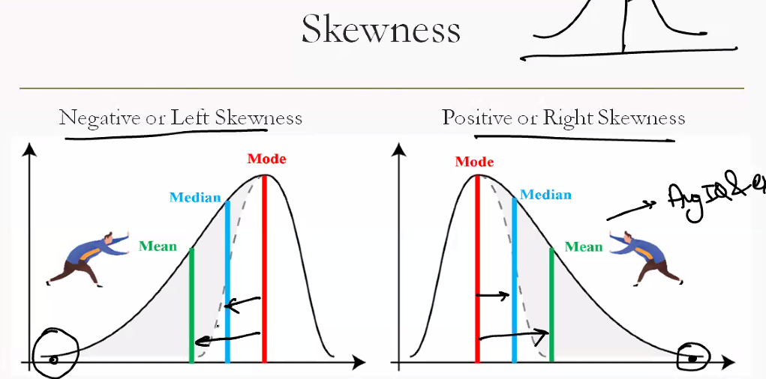

Kurtosis: A Measure of Peakedness and Tails

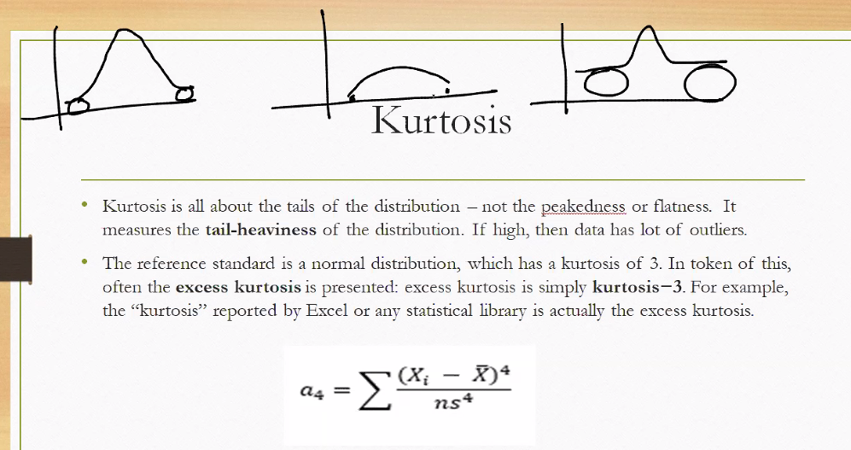
Kurtosis is a statistical measure that describes the shape of a distribution’s peak and the weight of its tails. While skewness tells us about symmetry, kurtosis tells us how concentrated or dispersed the data is around the mean.
🔍 Key Concepts
- Kurtosis compares the shape of a distribution to a normal distribution, which has a kurtosis of 3 (sometimes reported as 0 when using excess kurtosis).
📊 Types of Kurtosis
Type | Description | Tail Behavior
Mesokurtic | Normal peak and tails (Kurtosis ≈ 3) | Moderate tails
Leptokurtic | Sharp peak, heavy tails (Kurtosis > 3) | More outliers
Platykurtic | Flat peak, light tails (Kurtosis < 3) | Fewer outliers
- Leptokurtic distributions are riskier — more extreme values.
- Platykurtic distributions are more stable — fewer surprises.

• Leptokurtic distribution: This is the technical term for high kurtosis.
• Sharp central peak: Most data points are tightly clustered around the mean.
• Heavy tails: There are more extreme values (outliers) than you'd expect in a normal distribution.
Interpretation
Feature | High Kurtosis (Leptokurtic)
Peak shape | Very sharp and narrow
Tail weight | Heavy — more outliers
Risk implication | Higher risk or volatility
Example | Stock returns, financial losses, test scores with few very high/low values

🧮 Formula for Kurtosis
$$γ_{2}=\frac{1}{Nσ^{4}}\sum_{i=1}^{N}{}(x_{i}-μ)^{4}$$
Where:
- $γ_{2}$= kurtosis
- $N$= number of data points
- $σ$= standard deviation
- $x_{i}$= each data point
- $μ$= mean of the dataset
This formula uses fourth powers to emphasize extreme deviations and tail weight.

🧠 Why Kurtosis Matters
- Reveals outlier sensitivity and tail risk in data.
- Crucial in finance, quality control, and distribution modeling.
- Helps assess whether data meets assumptions for parametric tests.

📈 What Is Kurtosis?
Kurtosis measures the tailedness of a distribution — how heavy or light the tails are compared to a normal distribution.
- A normal distribution has a kurtosis of 3.
- This value includes both the peak and the tails.

🔍 What Is Excess Kurtosis?
To make interpretation easier, we often use excess kurtosis, defined as:
$$\text{Excess Kurtosis}=\text{Kurtosis}-3$$

This compares a distribution directly to the normal distribution:
Excess Kurtosis | Interpretation | Shape Characteristics
= 0 | Mesokurtic | Normal peak and tails
> 0 | Leptokurtic | Sharp peak, heavy tails (more outliers)
< 0 | Platykurtic | Flat peak, light tails (fewer outliers)
🧠 Why It Matters
- Excess kurtosis helps identify whether a dataset has more or fewer extreme values than expected.
- It’s widely used in finance, quality control, and statistical modeling to assess risk and distribution shape.

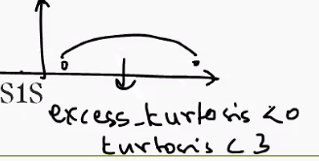

Platykurtic Distributions and Excess Kurtosis
In statistics, kurtosis measures the "tailedness" of a distribution — how sharp the peak is and how heavy the tails are compared to a normal distribution.
🧮 Key Definitions
- Kurtosis of a normal distribution = 3
- Excess Kurtosis = Kurtosis − 3
So:
- If kurtosis < 3, then excess kurtosis < 0
- This indicates a platykurtic distribution
📊 Characteristics of Platykurtic Distributions
- Flat peak: Data is more evenly spread around the mean
- Light tails: Fewer extreme values or outliers
- Lower concentration near the mean compared to a normal distribution
- Excess Kurtosis < 0
Example:
- Uniform distributions or test scores where most students perform similarly without extreme highs or lows.
🧠 Why It Matters
- Platykurtic data is less risky in fields like finance or quality control.
- It suggests consistency and predictability, with fewer surprises.
- Helps determine whether parametric tests assuming normality are appropriate.
Type | Kurtosis Value | Excess Kurtosis | Shape Characteristics | Tail Behavior
Platykurtic | < 3 | < 0 | Flat peak, broad distribution | Light tails, fewer outliers
Mesokurtic | = 3 | = 0 | Normal bell curve | Moderate tails
Leptokurtic | > 3 | > 0 | Sharp peak, narrow center | Heavy tails, more outliers

Key Insights
- Platykurtic: Indicates consistency and low risk; data is evenly spread.
- Mesokurtic: Matches the normal distribution; baseline for comparison.
- Leptokurtic: Signals volatility and tail risk; more extreme values.

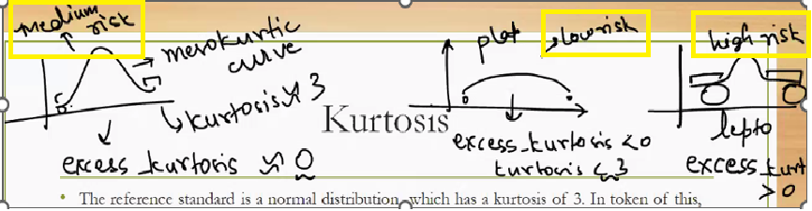
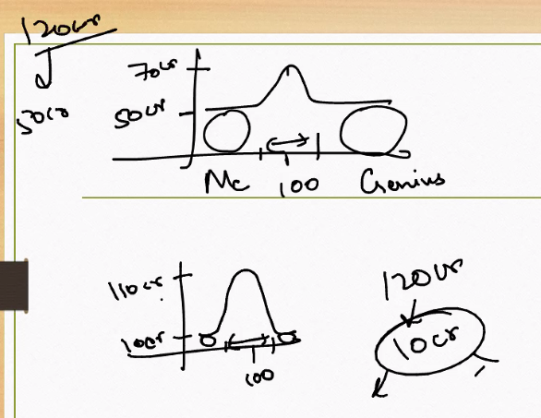
Me: Mental retardness
Genius: Genius people

Fishers Score :
Fisher’s score in kurtosis refers to the original definition of kurtosis developed by Ronald Fisher, where the kurtosis of a normal distribution is set to 3. This is the basis for calculating excess kurtosis, which helps compare other distributions to the normal.
📈 Fisher’s Kurtosis vs. Excess Kurtosis
🔹 Fisher’s Definition
- Kurtosis = 3 for a normal distribution.
- This includes both the peak and the tails of the distribution.
- Fisher’s score is based on the fourth standardized moment:
$$\text{Kurtosis}=\frac{1}{Nσ^{4}}\sum_{i=1}^{N}{}(x_{i}-μ)^{4}$$
🔹 Excess Kurtosis
- Defined as:
$$\text{Excess Kurtosis}=\text{Kurtosis}-3$$
- Makes interpretation easier:
  - 0 → Mesokurtic (normal)
  - > 0 → Leptokurtic (heavy tails)
  - < 0 → Platykurtic (light tails)
🧠 Why Fisher’s Score Matters
- It’s the standard reference point for kurtosis in statistical software and textbooks.
- Helps determine whether a dataset has more or fewer outliers than expected under normality.
- Used in normality tests, risk modeling, and distribution profiling.

Here’s a visual comparison of Fisher’s kurtosis for a normal distribution vs a heavy-tailed distribution. The normal curve shows near-zero kurtosis, while the heavy-tailed Student’s t-distribution shows high positive kurtosis.
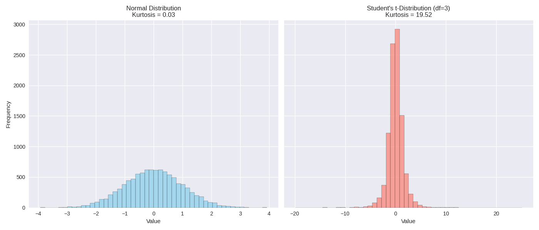
📊 What the Graph Shows
- Left Panel (Normal Distribution)
  - Generated with mean = 0, std = 1
  - Histogram is bell-shaped and symmetric
  - Fisher’s kurtosis ≈ 0 → matches normal expectations
- Right Panel (Student’s t-distribution, df = 3)
  - Heavy tails and sharper peak
  - More extreme values (outliers)
  - Fisher’s kurtosis ≫ 0 → leptokurtic behavior
🧠 Why This Matters
- Fisher’s kurtosis helps quantify how much a distribution deviates from normality in terms of tail weight.
- High kurtosis signals greater risk or volatility, especially in finance or quality control.
- This comparison shows how kurtosis captures subtle but important differences in distribution shape.

Perfect — here’s a side-by-side compiled table of the main coefficients used in skewness and kurtosis, including Fisher’s definition. This gives you a quick reference for formulas, ranges, and interpretations:
📊 Coefficients of Skewness and Kurtosis
Measure | Formula | Normal Distribution Value | Range / Interpretation | Meaning
Karl Pearson’s Coefficient of Skewness (Mode form) | $$\frac{\text{Mean}-\text{Mode}}{σ}$$ | 0 | > 0 → Positive skew <br> < 0 → Negative skew | Direction & degree of asymmetry
Karl Pearson’s Coefficient of Skewness (Median form) | $$\frac{3(\text{Mean}-\text{Median})}{σ}$$ | 0 | Same interpretation as above | Used when mode is unavailable
Fisher’s Kurtosis | $$\frac{1}{Nσ^{4}}∑(x_{i}-μ)^{4}$$ | 3 | > 3 → Leptokurtic <br> = 3 → Mesokurtic <br> < 3 → Platykurtic | Peakedness & tail weight
Coefficient of Kurtosis (Excess Kurtosis) | Kurtosis − 3 | 0 | > 0 → Heavy tails <br> < 0 → Light tails | Comparison against normal distribution
🧠 Key Takeaways
- Skewness coefficients → tell you if the distribution leans left or right.
- Kurtosis coefficients → tell you if the distribution is flatter, normal, or more peaked than normal.
- Both are dimensionless coefficients, making them comparable across datasets regardless of units.

Karl Pearson’s Coefficient of Skewness
Karl Pearson introduced a simple and intuitive formula to measure the skewness of a distribution — that is, how asymmetrical it is around the mean.
🧮 Formula
$$S_{k}=\frac{\text{Mean}-\text{Mode}}{σ}$$
Where:
- $S_{k}$= Pearson’s coefficient of skewness
- Mean = average value of the dataset
- Mode = most frequent value
- $σ$= standard deviation
🔍 Interpretation
- $S_{k}=0$→ perfectly symmetrical distribution
- $S_{k}>0$→ positively skewed (tail on the right)
- $S_{k}<0$→ negatively skewed (tail on the left)

📊 When to Use
- Best for unimodal distributions (one clear peak).
- Useful when mode is known or easily estimated.
- Offers a quick way to assess asymmetry without computing third moments.

🧠 Why It Matters
- Pearson’s method is easy to compute and interpret.
- It connects skewness directly to familiar measures: mean, mode, and standard deviation.
- Helps in data profiling, distribution analysis, and preprocessing decisions (e.g., whether to transform data).

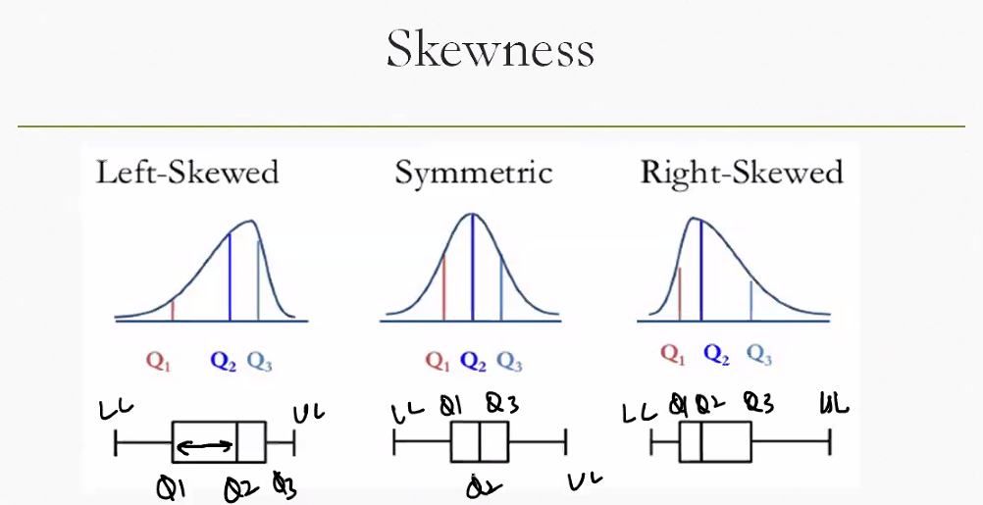

Skewness Through Box Plots
Box plots are powerful visual tools that reveal the symmetry or skewness of a dataset by showing how data is distributed across quartiles.
🔍 Key Components of a Box Plot
- Q1 (Lower Quartile): 25% of data falls below this point
- Q2 (Median): Middle value (50th percentile)
- Q3 (Upper Quartile): 75% of data falls below this point
- Whiskers: Extend to minimum and maximum values (excluding outliers)
- Box: Spans from Q1 to Q3, showing the interquartile range (IQR)

Types of Skewness in Box Plots
1. Left-Skewed (Negative Skew)
- Longer left whisker
- Median closer to Q3
- Tail extends to the left
- Mean < Median < Mode
- Example: Age at retirement — most retire around 60, few earlier
2. Symmetric Distribution
- Whiskers are roughly equal
- Median centered between Q1 and Q3
- Mean ≈ Median ≈ Mode
- Example: Heights of adult males in a population
3. Right-Skewed (Positive Skew)
- Longer right whisker
- Median closer to Q1
- Tail extends to the right
- Mode < Median < Mean
- Example: Income distribution — most earn average, few earn much more

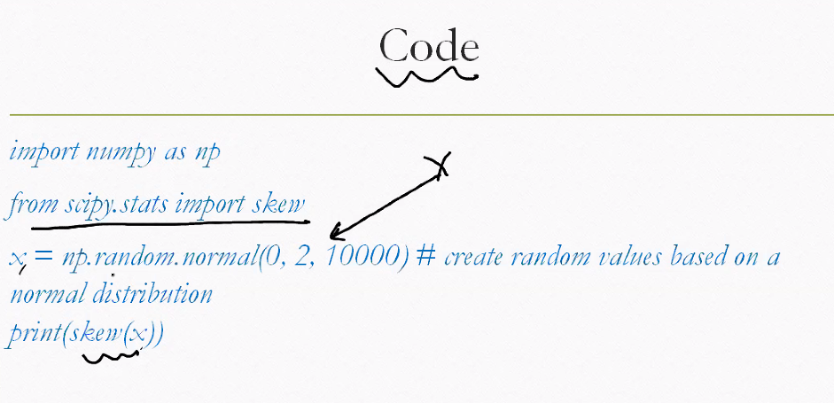

import numpy as np
from scipy.stats import skew

x = np.random.normal(0, 2, 10000) # create random values based on a normal distribution
print(skew(x))

